For Immediate Release
Nisga’a Nation Brings Messge of Joint Prosperity and Unity to Historic First Ministers’ and First Nations Meeting
October 27, 2026 – New Aiyansh, B.C. – On October 26, 2026, Leaders representing Canada’s 29 First Nations who have entered into modern treaties and self-government agreements (MT/SGs) were welcomed as partners by First Ministers to the First Ministers’ and First Nations meeting (FMFNM) in Ottawa. President Eva Clayton and CEO Andrew Robinson represented the Nisga’a Nation and formed part of the broader MT/SG delegation. President Clayton also attended the meeting in her capacity as Co-Chair of the Land Claims Agreements Coalition (LCAC). The Assembly of First Nations and Alberta Treaty 6, 7, and 8, and Blackfoot Confederacy Chiefs were also present.
In his opening remarks, Prime Minister Carney welcomed First Nations Leaders, including President Clayton and MT/SG Leaders, and emphasized that the meeting was an opportunity to work together to build a stronger, fairer, and more inclusive Canada. In her remarks, President Clayton agreed with the Prime Minister, highlighting that Canada’s nation-building ambitions and MT/SGs’ own priorities can advance together, creating stronger communities, thriving economies and lasting prosperity. She emphasized that to do that, modern treaties and self-government agreements must be fully respected and implemented, and Canada must invest in MT/SGs.
Throughout the meeting, Leaders emphasized that MT/SGs have a unique status as governments within Canada’s Federation with established rights, jurisdictions and responsibilities. They also underscored that strong economies and thriving communities go hand in hand, and that investments in health and wellbeing, housing, infrastructure and public safety help create the foundations for healthy families, resilient communities and sustained economic development.
MT/SG Leaders advanced concrete proposals to strengthen whole-of-government treaty implementation, address barriers to exercising Indigenous jurisdiction, and invest in infrastructure, language revitalization, and lands and resource management through their existing joint fiscal processes. They called for renewed direct engagement with the Prime Minister through an Intergovernmental Leaders’ Forum in early 2027.
Prime Minister Carney discussed new economic opportunities for First Nations to develop, operate and share in the wealth that Canada’s projects create, citing the Ksi Lisims LNG Project – co-developed by the Nisga’a Nation – as a strong example to build on. In response, MT/SG Leaders outlined a practical path to strengthen partnerships, advance shared priorities and turn opportunities for collaboration into meaningful results. This discussion led to Prime Minister Carney’s commitment to work with MT/SGs to develop a Path Forward Agreement and establish a collaborative process to advance shared priorities, which MT/SG Leaders welcomed. MT/SGs anticipate the agreement will focus on early participation in major projects, access to capital and ownership opportunities, workforce development, community investment and long-term economic partnerships and create a foundation for lasting collaboration and shared prosperity.
“Our historic participation at the FMFNM was an important step in recognizing the contributions of MT/SGs to Canada’s future” said Eva Clayton, President of the Nisga’a Nation and Co-Chair of the Land Claims Agreement Coalition. “I am pleased with the outcome of the meeting, and I look forward to working with the Prime Minister to convert his commitments into measurable actions”.
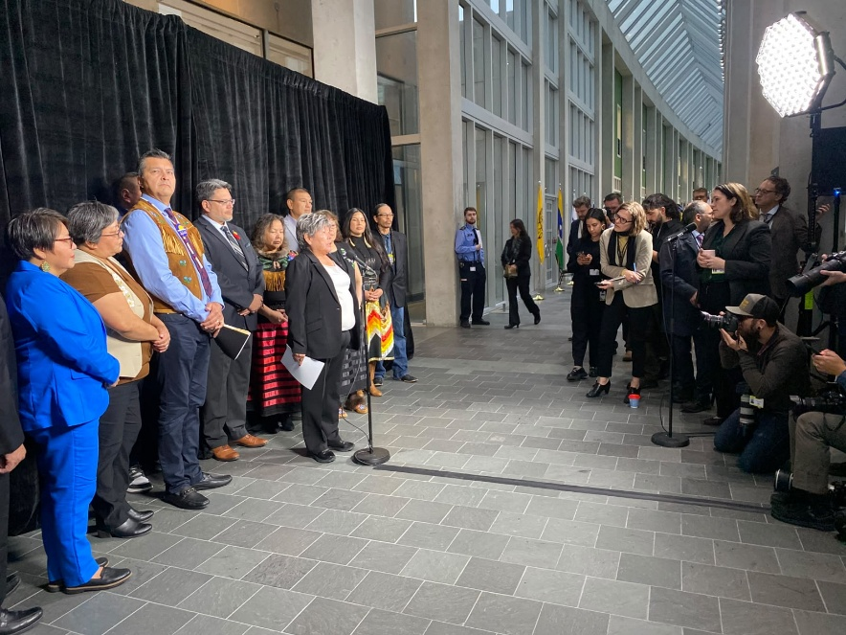

Media Inquiries:
Paul Mercer, Communications Manager
Email: paulm@nisgaanation.ca
Tel: (250) 633-3000
Web: www.nisgaanation.ca

